***Opening Prayer***

God of each day and each moment,

you call us to make choices:

choices about how we will live,

how we will use our time and resources.

You call us to make decisions:

who we will look out for,

what we will commit to,

who we will follow.

As we come before you now,

bless us with wise discernment and loving compassion,

that we may serve you – and one another –

after the example of Jesus, our Lord and Saviour.

**Amen**.

***Gleaning***

In Old Testament times we read of people gleaning. This was the practice of following the harvesters and picking up scraps that have been left. This applied to cereal crops where the harvester was told not to go back and pick up strands that had been dropped because they were for the poor. Kinder farmers might pull a few strands from the sheaves as they went.

When fruit was being harvested any that falls to the ground was for the gleaners. All this was laid out in the Torah (Leviticus 19: 9-10). However, women gleaning, were often prey to the men harvesting.

***Read Ruth 2***

***Reflect***: so, what’s the story?

Retell the story as if Ruth writes it. (You might want to write this down or just rehearse it in your mind). From your personal experience, read ‘into’ or ‘between’ the text. Using your own experience to read ‘what is not said’ in the text is one of the main aspects of a feminist approach to reading the Bible.

***Relevance***: think about Ruth as a migrant or seasonal worker in the UK today. What would be her needs and fears? How might the local church support and welcome her?

What are our churches already doing to welcome and support outsiders?

***Questions to reflect upon.***

1. Why do you think Ruth went to glean in the fields of Boaz?
2. In what ways did Boaz treat Ruth differently to the other gleaners?
3. What reasons can you give for Boaz behaving in this way?

***A personal prayer***

Choose kindness over cruelty,

generosity over greed,

patience over retaliation,

peace over conflict,

willingness over reluctance,

conviction over complacency;

and be blessed in the name of God,

Father, Son and Holy Spirit, this week and always.

**Amen.**

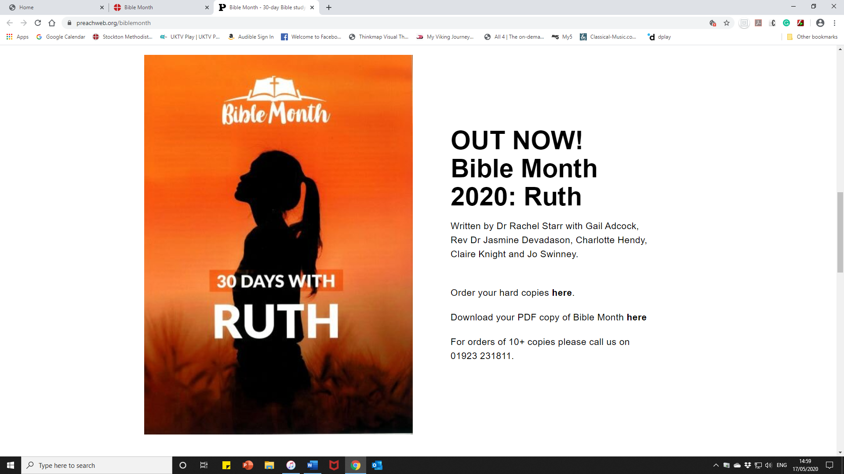

**Mid-week**

**Session 2**



**Ruth meets Boaz**

The two women have arrived in Bethlehem and while they have been accepted, they have had no offers of help. As it is the barley harvest Ruth decides to exercise her right to glean.