***Opening Prayer***

With hearts full of hope,

minds open to receive,

and ears tuned to hear,

we draw near, Lord God, to learn

and to share your all-powerful, guiding truth.

**Amen**.

***Family Tree***

**Elimelech = Naomi**



**Mahlon and Chilion**

**=Ruth =Orpah**

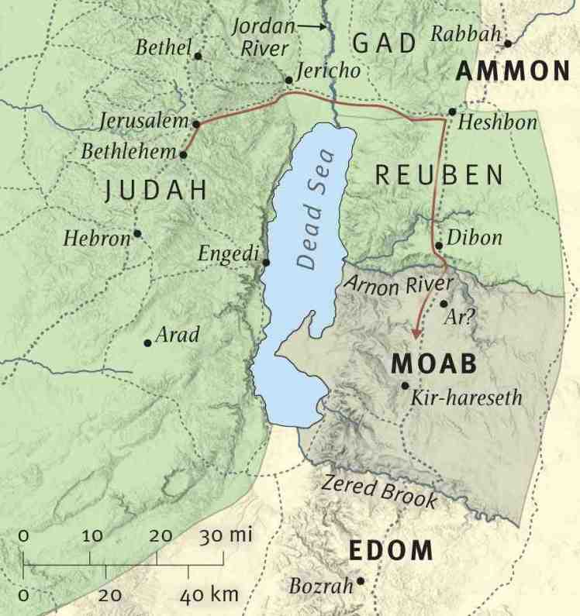

***Imagine***: sit quietly for a moment and close your eyes, picturing the scene and everything about it. Put yourself in the shoes of your character. You may find it helpful to go through each of your five senses and think about what you can see, smell, touch, hear and taste as your character.

***Pray***: pray that just as this scene has come to life today, you might also become more aware of God’s presence in every aspect of your life.

***Make notes*** as you reflect on the story: -

a. What’s your role within the story/scene?

b. How do you feel?

c. Is there anything unique that you learn from this perspective?

d. What might reflecting on Jesus’ character say about this

person’s situation?

***Questions to reflect upon.***

1. Where do you consider your true home to be – where you grew up or where you are now?
2. Why do you think Naomi wanted to send her daughters-in-law back to their families?
3. Reading Ruth’s answer (verses 16-17), why do you think she wanted to stay with Naomi?

***A personal prayer***

Lord, nudge me

if I get so preoccupied with my own faith

that I neglect to share it with those around me.

Guide me in where and what to share,

that I may bring your joy to others.

**Amen.**

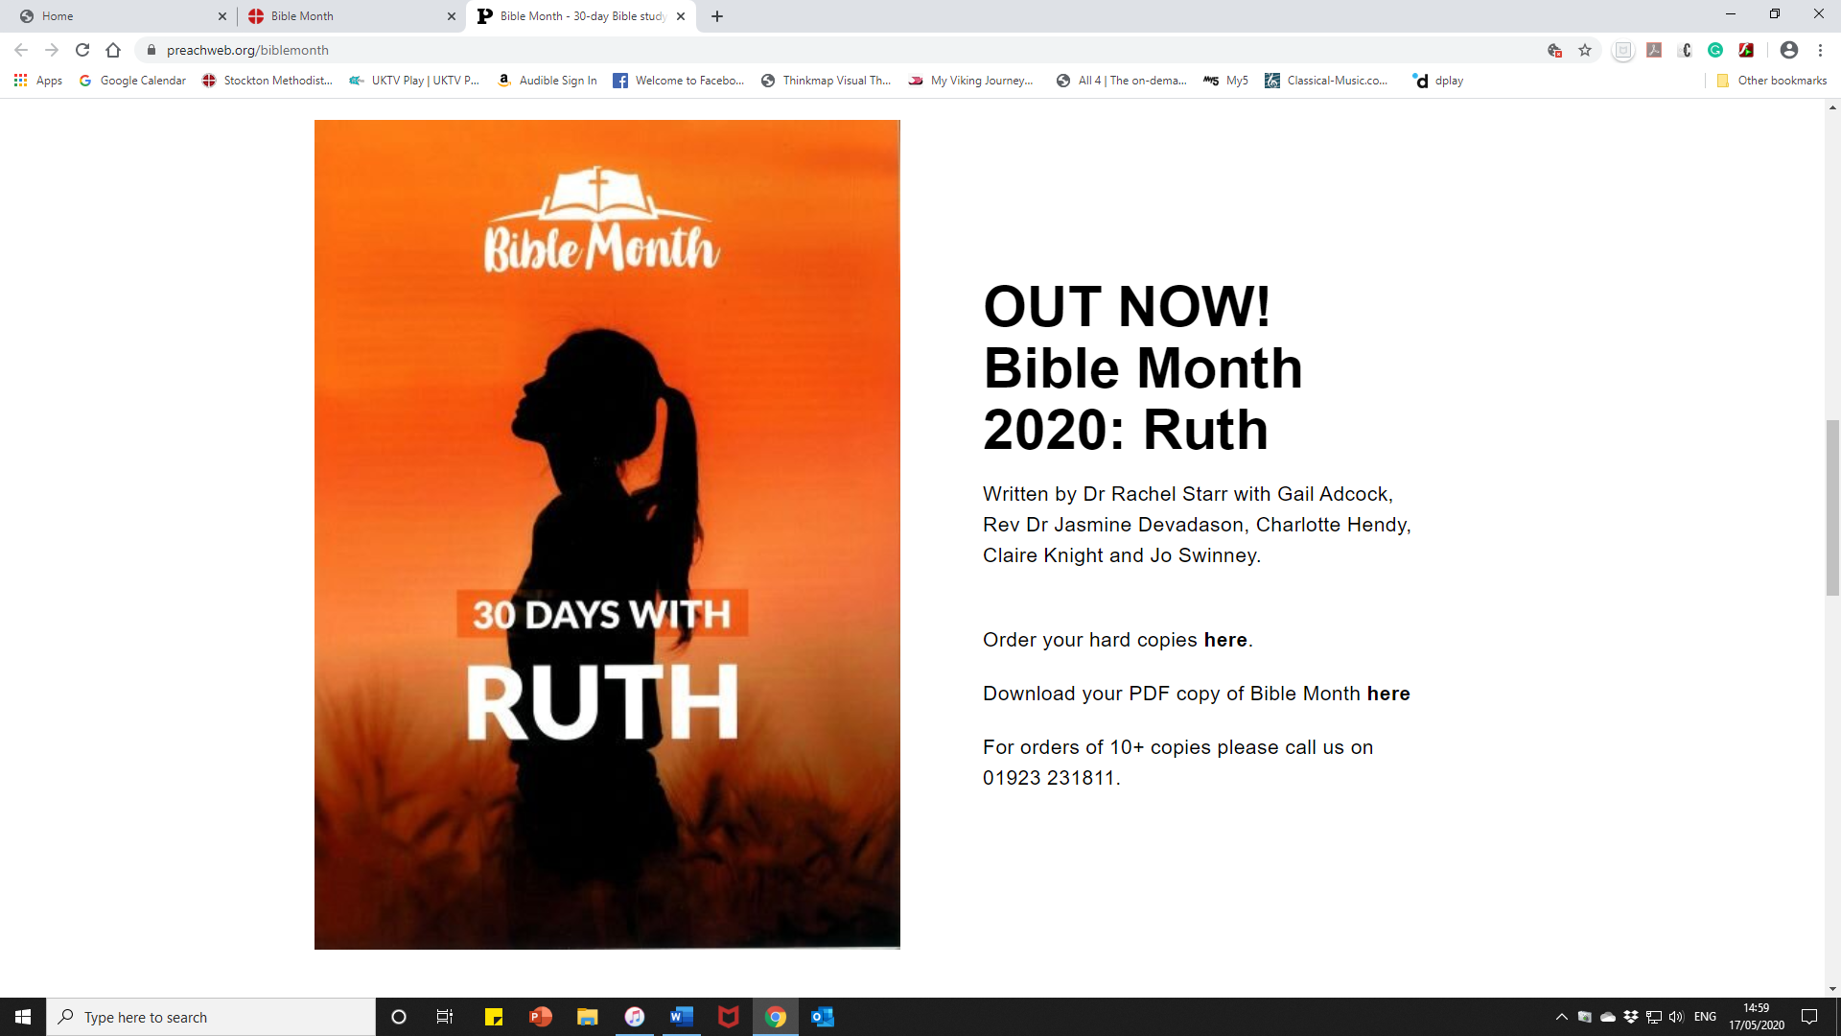

**Mid-week**

**Session 1**



**Getting the Big Picture**

The Book of Ruth is set in the period of the Judges, before Israel had any kings, about 1100 BC. Ruth, a Moabite, becomes an ancestor of King David. Some people later challenged the legitimacy of the son’s of David as a royal line.